  

TIJUANA INSTITUTE OF TECHNOLOGY

## ACADEMIC

DEPARTMENT OF SYSTEMS AND COMPUTATION COMPUTER SYSTEMS ENGINEERING

SEMESTER FEBRUARY- JULY 2022

## SUBJECT

BDD-1703SC9C Data Mining

Activity

Practice 1

# Teacher

MC JOSE CHRISTIAN ROMERO HERNANDEZ

# Student

17212327 -Aldarete Delgado Angel Esteban 17210659 - Villegas Carmona Damaris

Tijuana, BC April 26, 2022

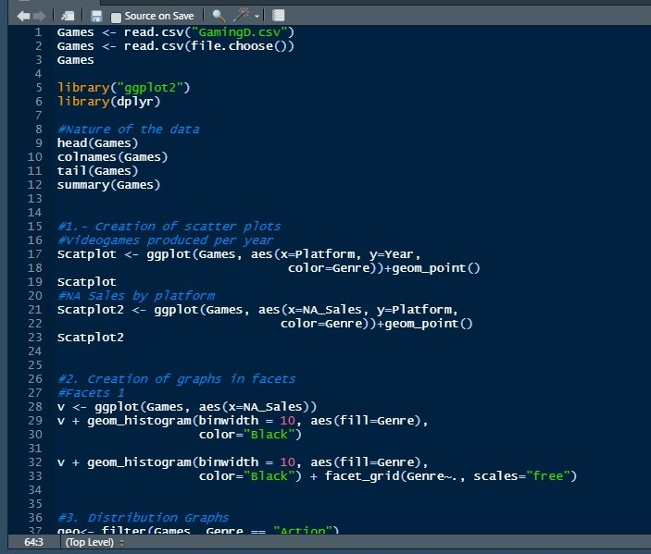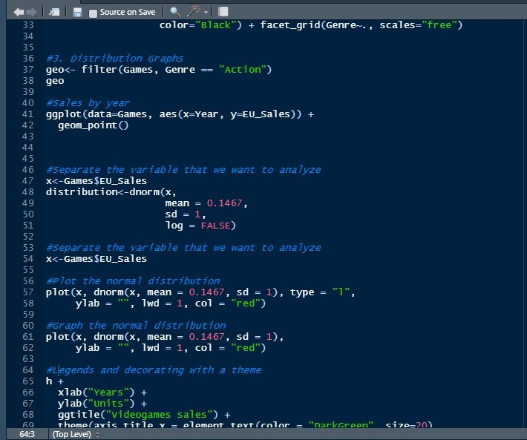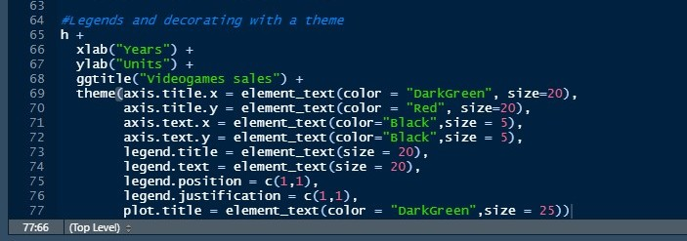**Code**

**1.-Scatter diagram**

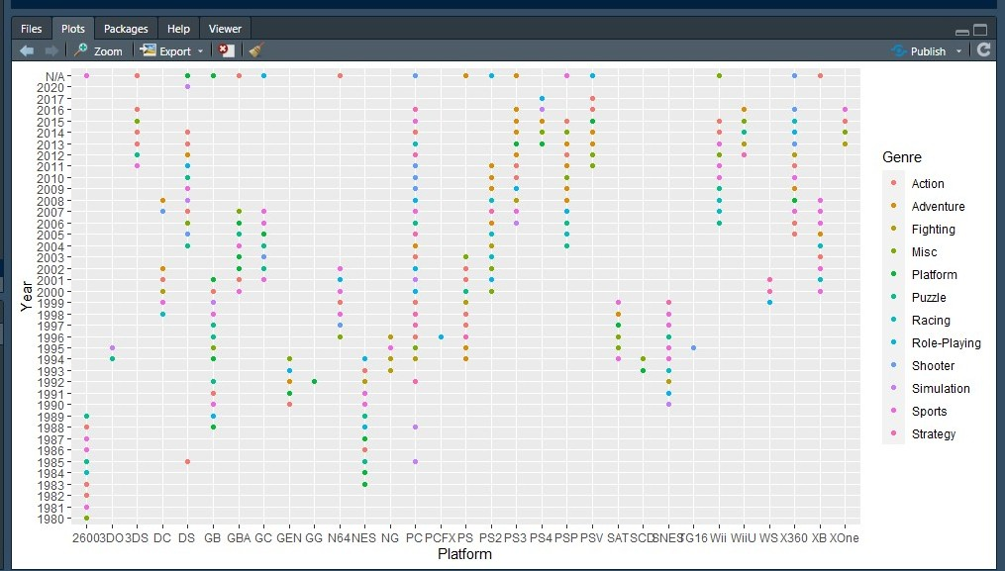Video games produced per year

NA Sales by platform

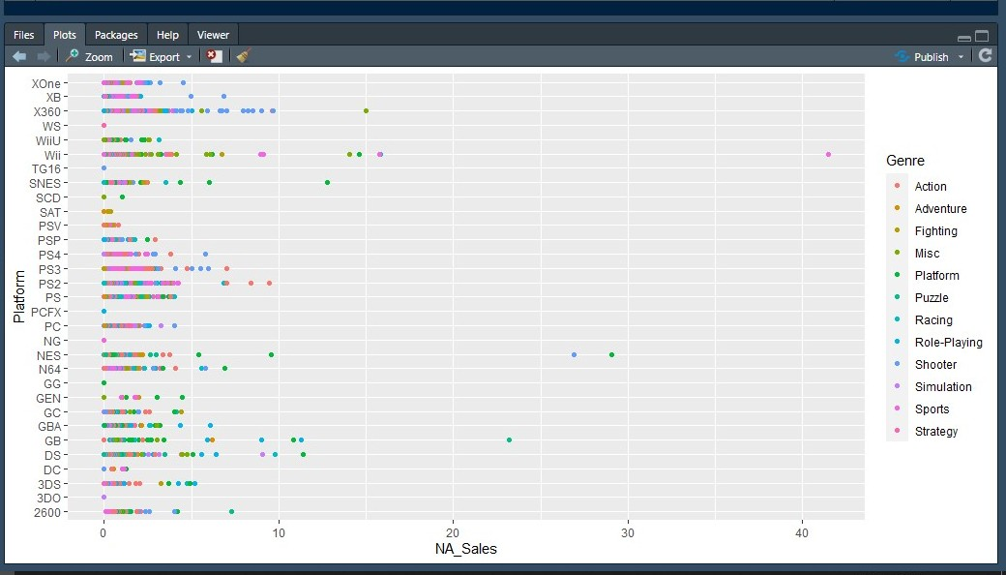

**2.- Facet**

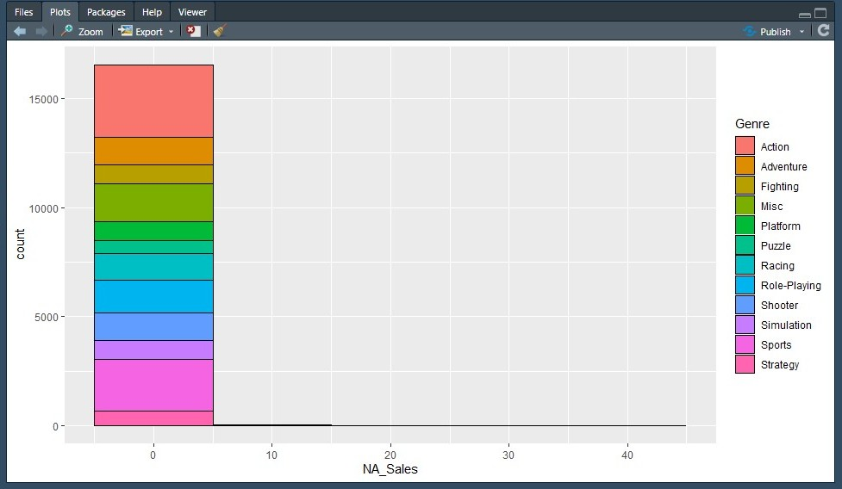

**graph 3.-Statistics graph**

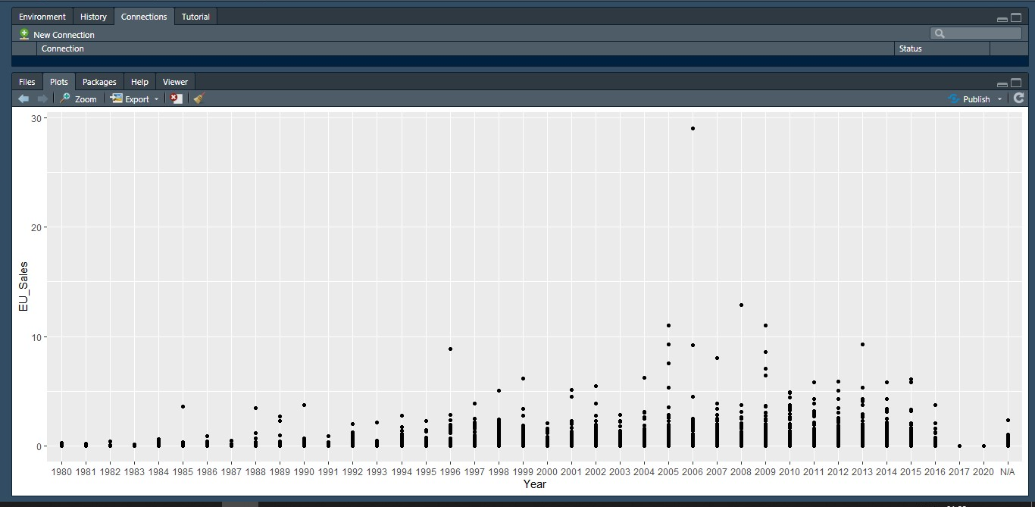Sales by year

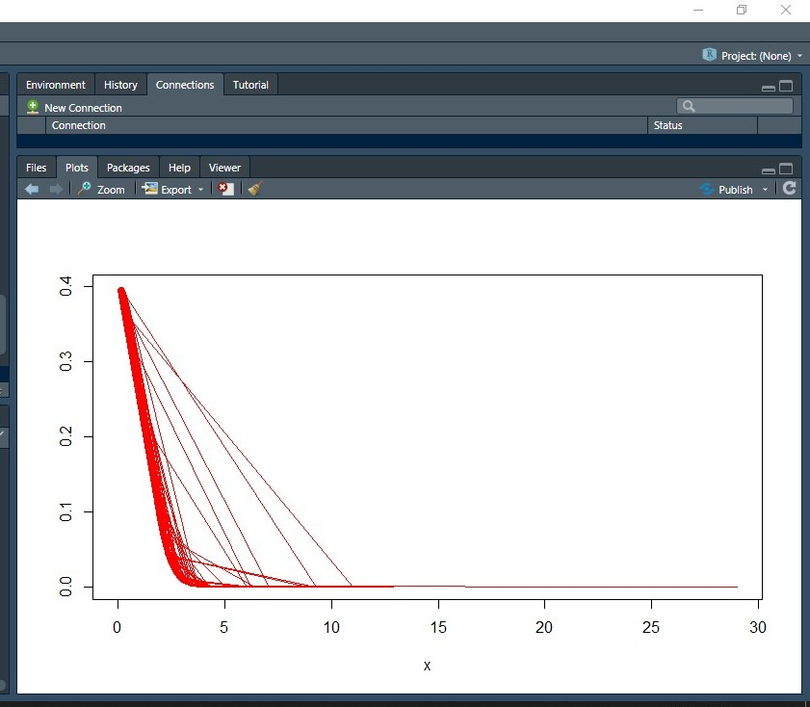Plot the normal distribution

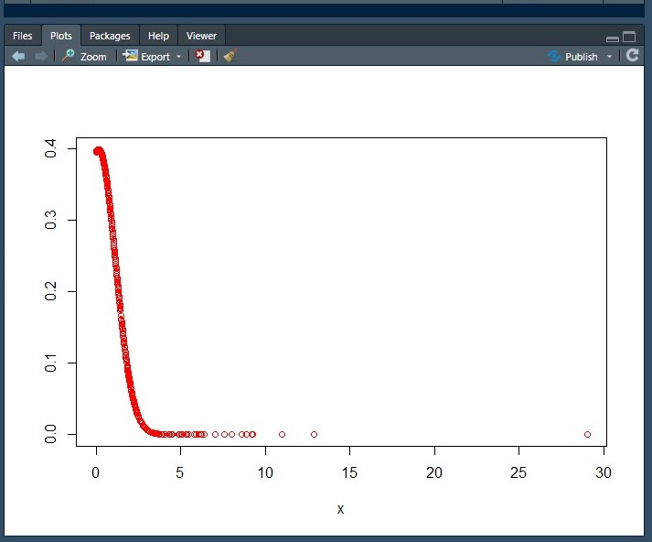

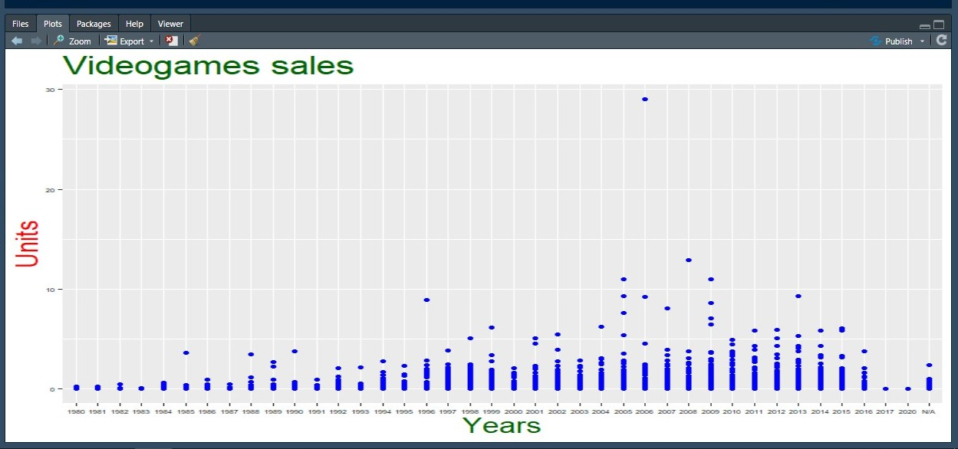Legends and decorating with a theme